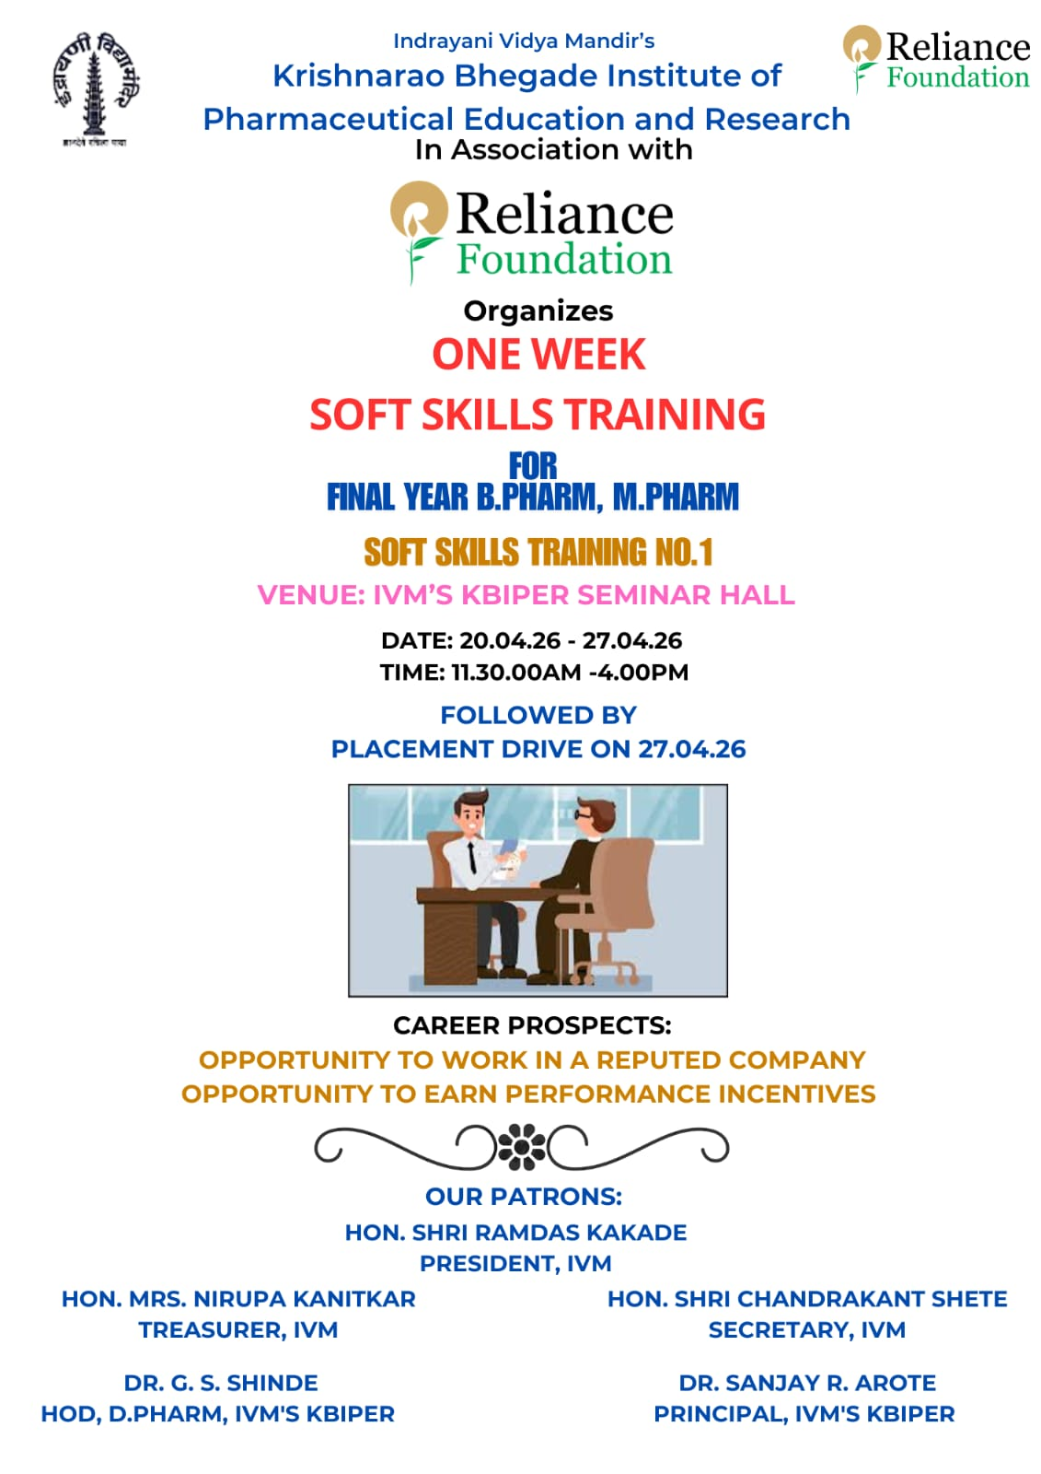REPORT

01 | Date of activity | 20/04/2026 to 27/04/26
02 | Batch details | Two batches RF - 70 and 71 conducted.
03 | Occasion of activity | Workshop on the topic,“ 21st Century Skills Initiative,Workplace Ready: Life and Employability Training” in collaboration with Reliance Foundation from 20th April 2026 to 27th April 2026”.
04 | Platform | Offline mode
05. | Objective | To provide guidance on soft skills, in order to face interviews confidently.
06 | Name of the Speaker | Mr. Shubham Sathe & Mr.Pramod Bhalerao (Trainers) and Mr.Prathamesh Vaidya & Shaibaz Shaikh (HR Team)
07 | Summary of lecture:  Indrayani Vidya Mandir’s Krishnarao Bhegade Institute of Pharmaceutical Education and Research, organized a workshop on the topic,,“ 21st Century Skills Initiative,Workplace Ready: Life and Employability Training”,in collaboration with Reliance Foundation from 20th April 2026 to 27th April 2026”.The guest speaker was heartily welcomed by Mr. Shyam S. Awate. Felicitation and introduction of the guest was done by Principal,Dr. Sanjay R. Arote.  Mr. Shubham Sathe & Mr.Pramod Bhalerao sir gave details on how to face interviews confidently and also how to improve soft skills for the same.  The following topics were covered by both the trainers throughout the week:  Day 1: 20/04/26: Introduction to soft skills: Self introduction & confidence building.  Day 2: 21/0426: Interview preparation: SWOT analysis. Strength and Weakness.  Day 3: 22/04/26: Goal Setting & Blind eye activity. Problem Solving Skills.
Day 4: 23/04/26: Communication Skills & Trust & lie activity. Behavior in Personal & Professional life.
Day 5: 24/04/26: Time management & Mock interview.LinkedIn & Naukri Profile.
Day 6: 25/04/26: Financial Planning & Revision of the whole week.
Day7: Mock Interview session by Mr.Prathamesh Vaidya & Shaibaz Shaikh (HR Team) also prepared students specifically for Infosys job related to Health and Insurance.
Students Feedback: The overall session was very interesting and students improved their skills to face the interview. Also the trainers made them aware of mistakes to avoid during an interview. Mock interview sessions helped them boost their confidence.
08 | Activity co-coordinator | Mr. S. S Awate, (TPO), Mr. Mayur Lohkare & Ms.Vilasini Pandav.

Mr. Shyam S. Awate Dr. Sanjay R. Arote
TPO Principal

Geotag photos of guest lecture
Saraswati Poojan
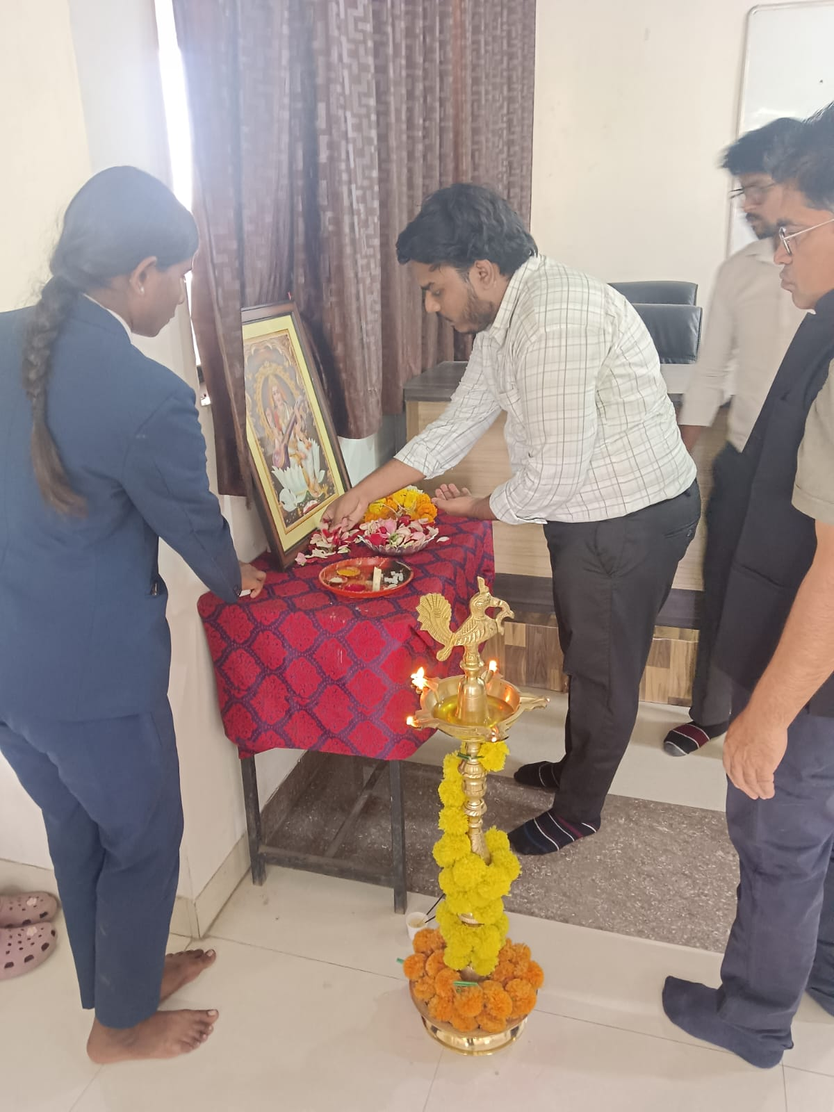 | 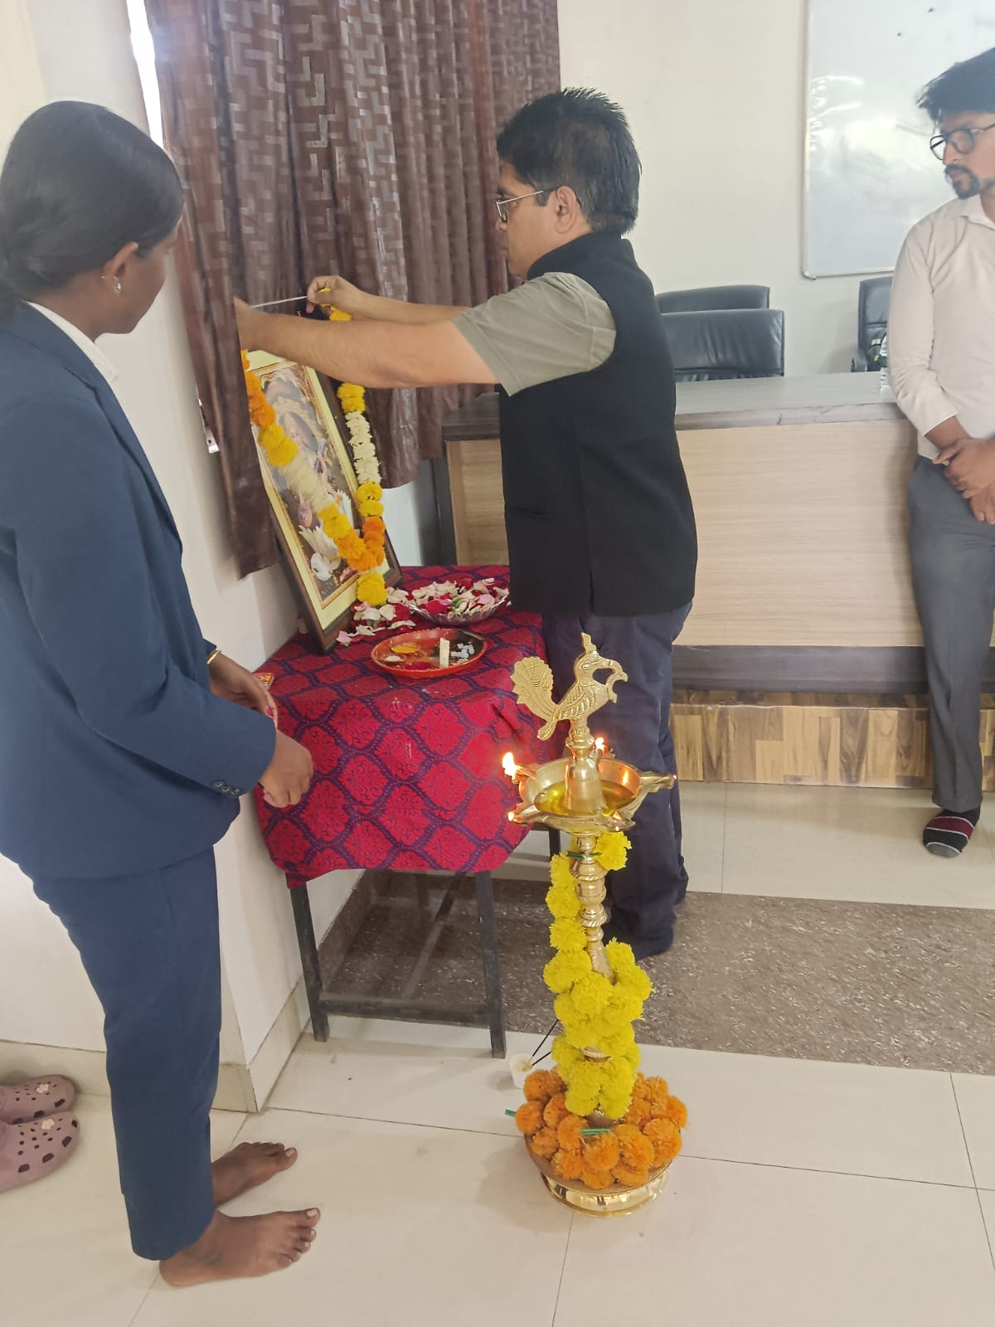 | 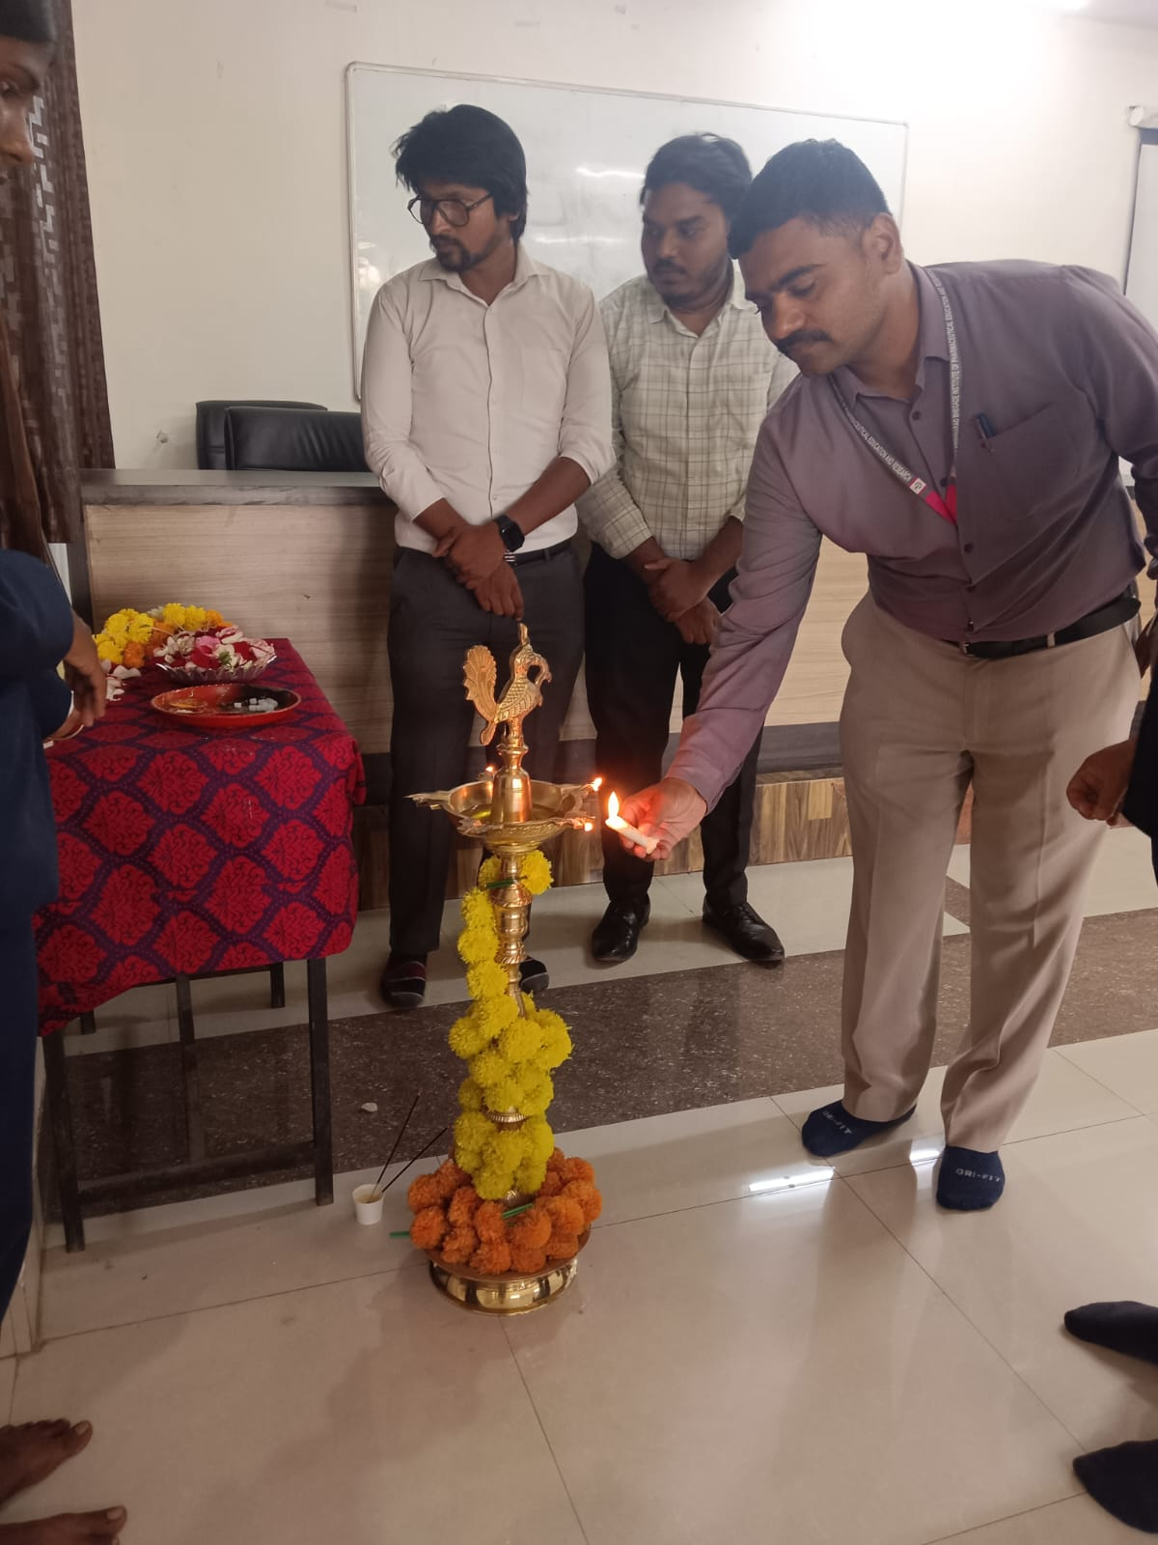
Intro by Mr. Shyam Awate | Felicitation of guests | Training session
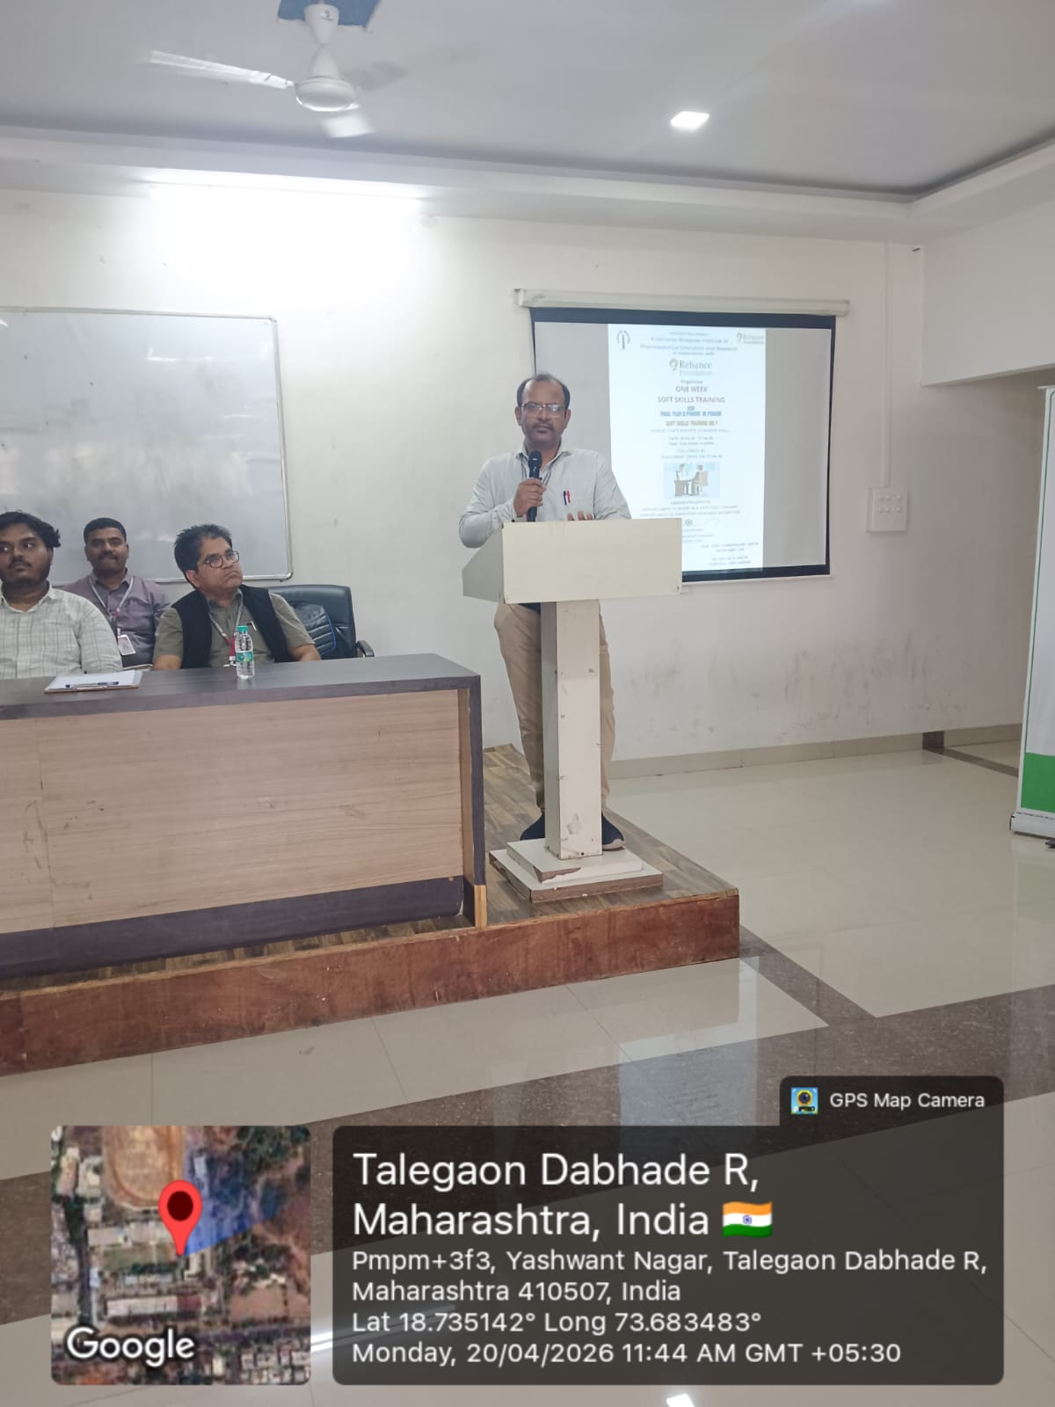 | 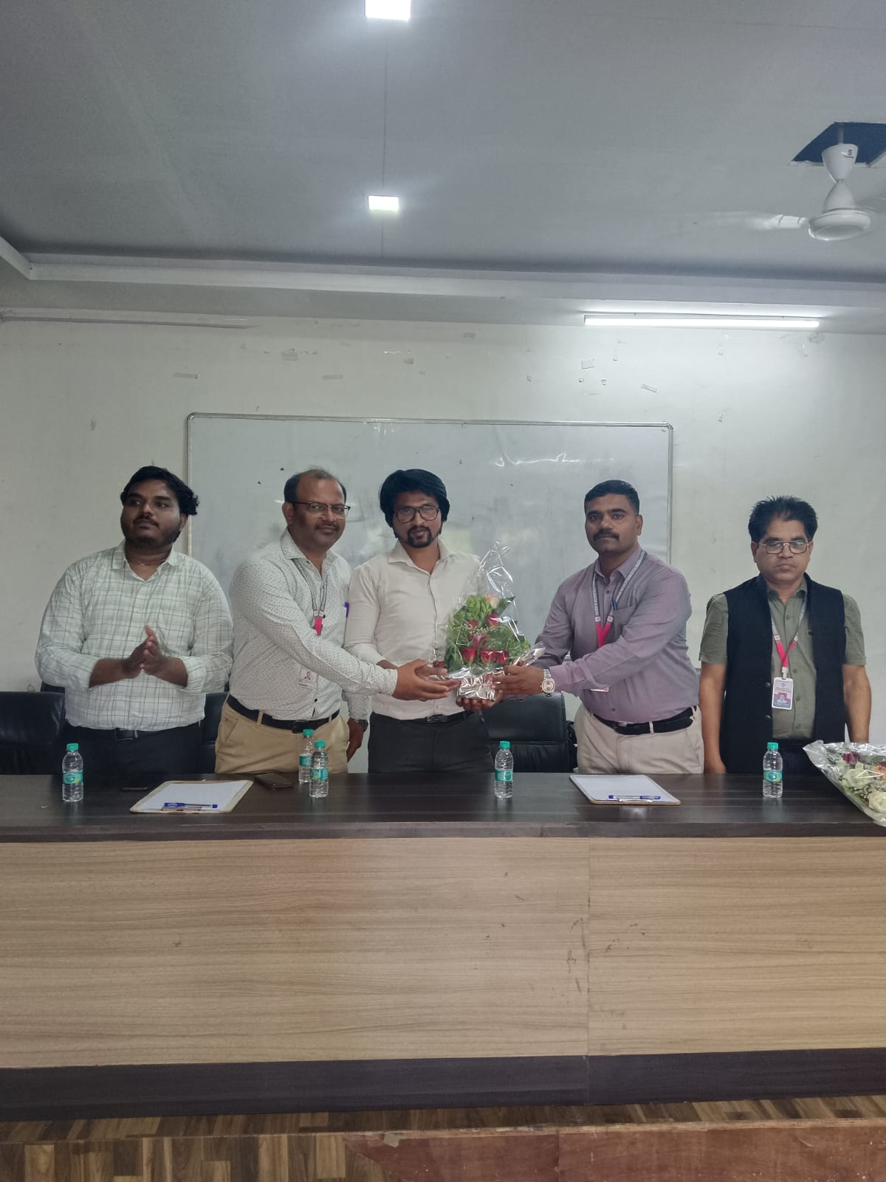 | 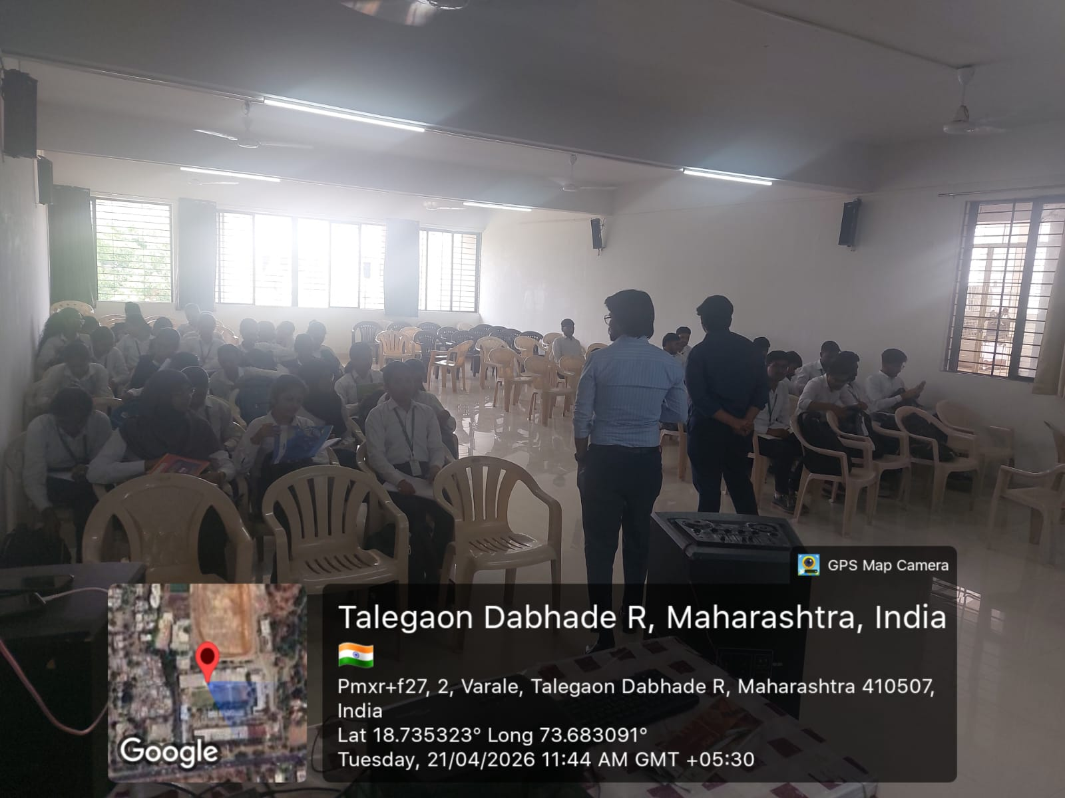

Mr. Shyam S. Awate Dr. Sanjay R. Arote
TPO Principal

